**REST SERVICE INTEGRATION USING WC3**

1. ng **new** todo-project --collection=@bb-cli/schematics
2. cd todo-project
3. npm run ng -- generate app --name=todo-app
4. npm **run** ng -- generate widget --name=todo-widget
5. Add generated and packaged data module   
   npm install @**backbase**/**reference**-**data**-**http**-**ang** –save
6. Widget architecture   
   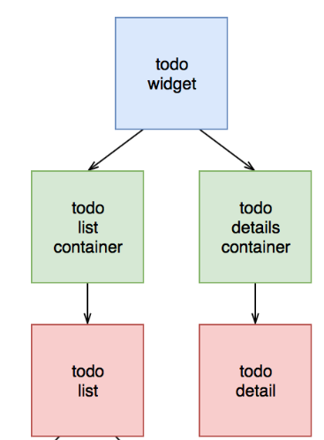
7. Enable Data mock service   
   **/apps/todo-app/src/environments/environments.ts**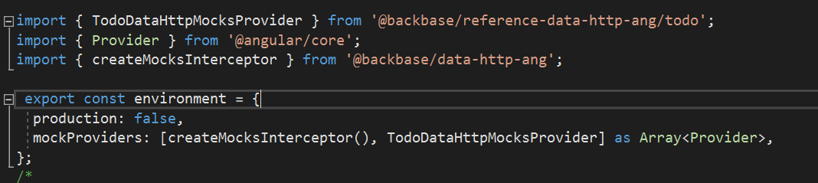
8. Render data in widget  
   **/libs/todo-widget/src/todo.service.ts**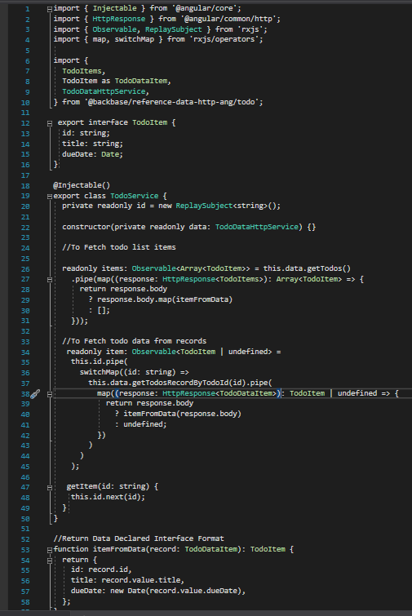
9. Add list Container   
   **/libs/todo-widget/src/todo-list-container.component.ts**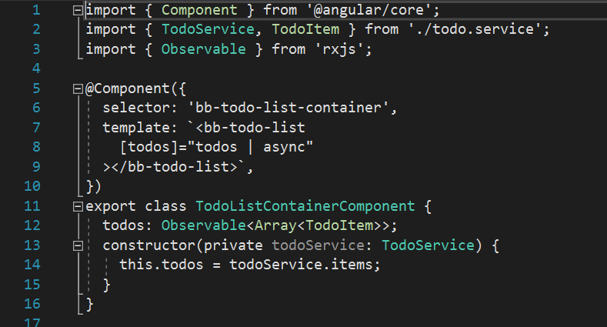
10. Add todo list component for rendering data in HTML  
    **/libs/todo-widget/src/todo-list.component.ts**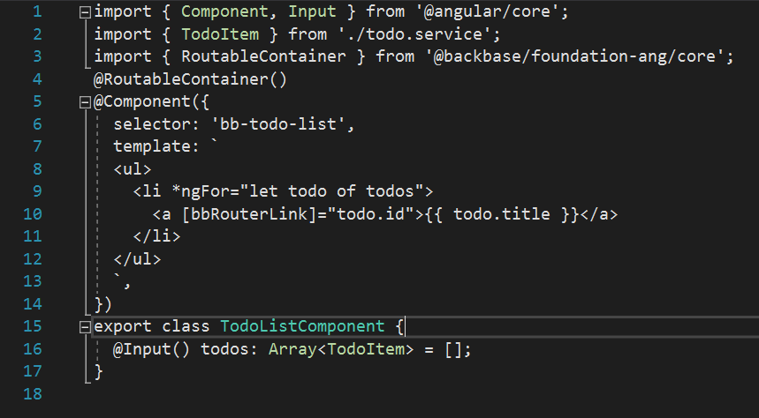
11. Add navigation   
    **/libs/todo-widget/src/todo-widget.component.ts**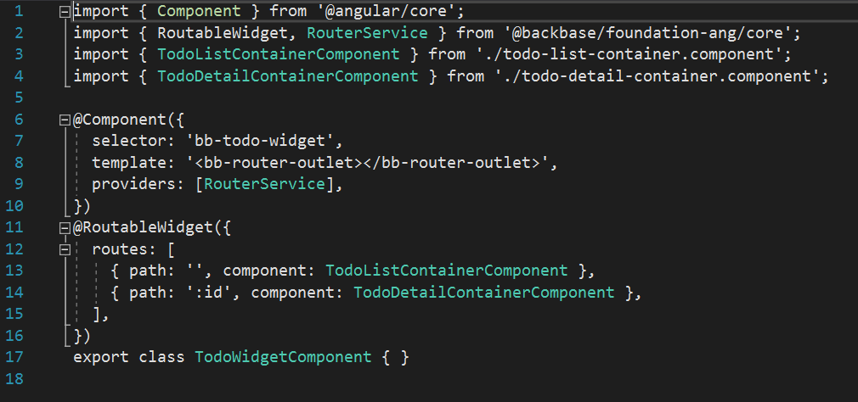
12. Create new tododetailcontainer  
    **/libs/todo-widget/src/todo-detail-container.component.ts**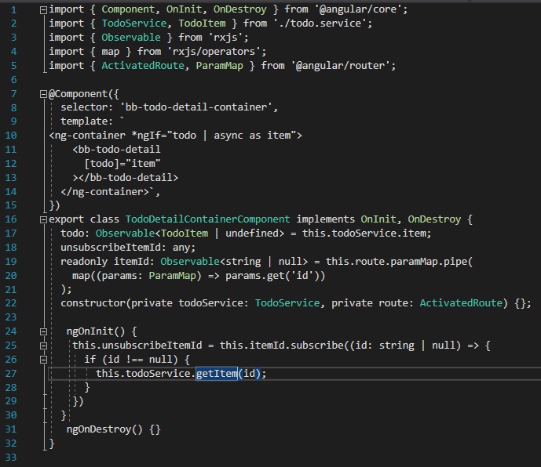
13. Add tododetailcomponent  
    **/libs/todo-widget/src/todo-detail.component.ts**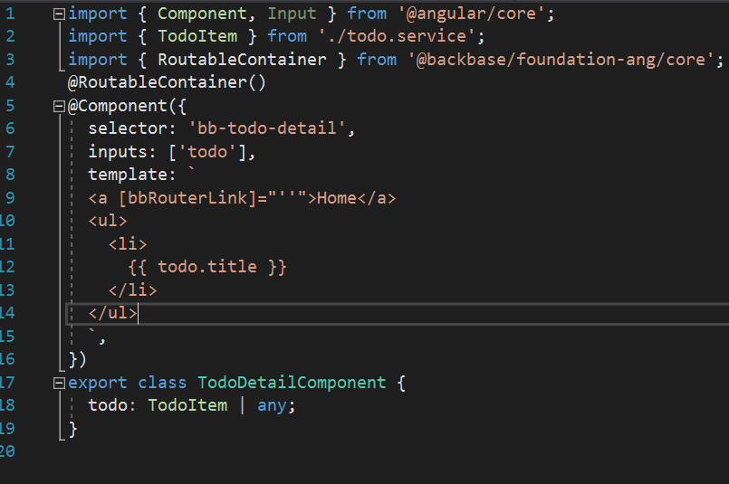
14. Adding dependencies to widget module  
    **/libs/todo-widget/src/todo-widget.module.ts**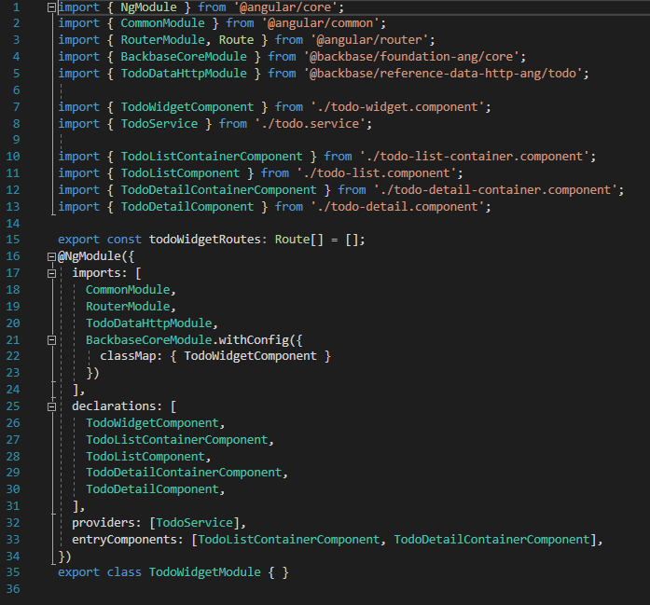
15. Add Widget module as dependency in app module  
    **/apps/rest-app/src/app/app.module.ts**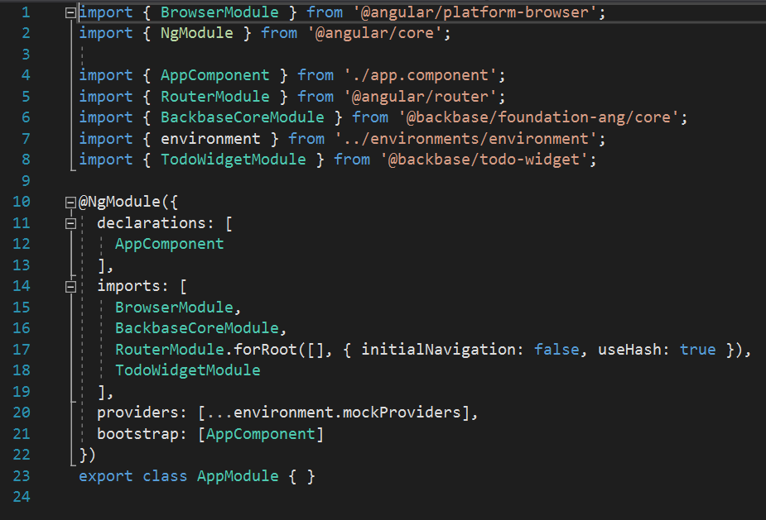
16. **Generating data module from raml**ng generate data-module --collection @**bb**-**cli**/**schematics** --name TodoData --ramlPath ./my-spec-folder/target/classes/api.raml  
      
    Given command will generate new data-module inside libs folder   
      
    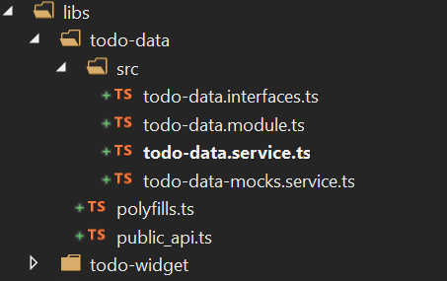
17. **Create interfaces according to JSON data   
    libs/todo-data/src/todo-data.interfaces.ts**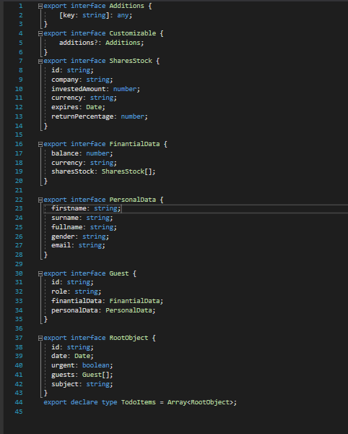
18. **Inject mock service dependency in widget service   
    libs/todo-widget/src/todo.service.ts**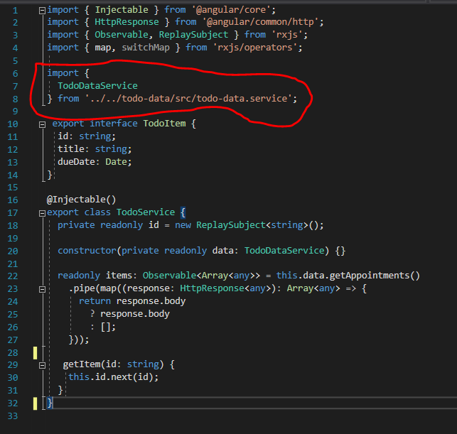
19. **Integrate Mock service dependency in widget module   
    libs/todo-widget/src/todo-widget.module.ts**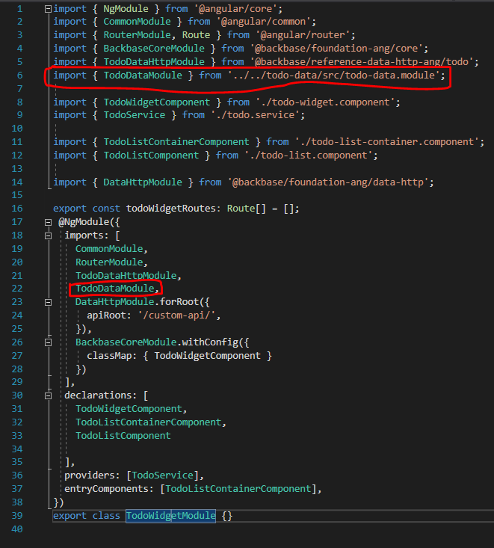
20. **Integrate data module mock service in environment  
    apps/todo-app/src/environments/environment.ts**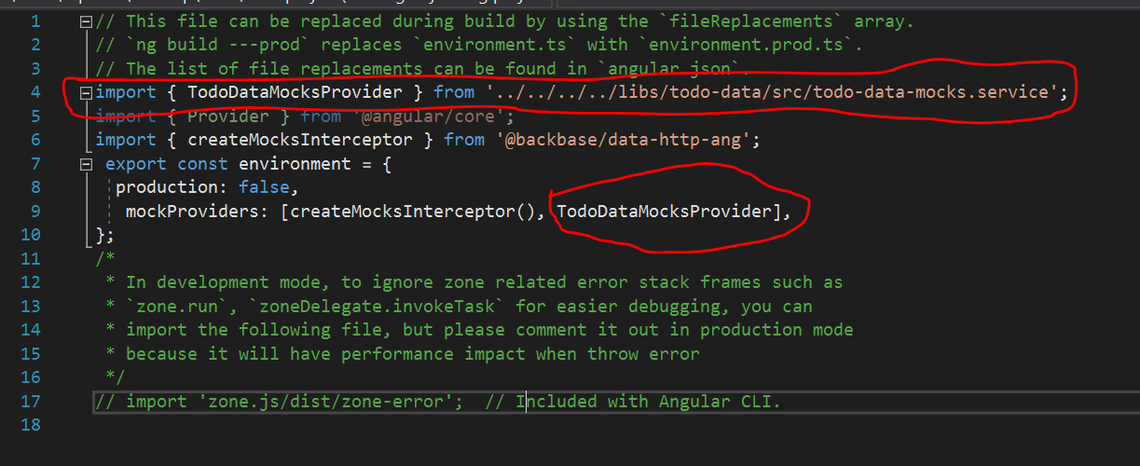
21. **Result**